

BSc in Software Development – Year 4 Mobile Applications Development 3 Project Part 2 – Implementation

*Author: Krystian Opryszek*

Table of Contents

Front End 2

Start Game 3

Options & Exit 4

In-Game Menus 5

Splash Screens 7

Control Mechanisms 8

Player movement 8

WASD 8

Jump 8

The Game 9

Level Design 10

Level Difficulty 10

Level 1 11

Level 2 11

Level 3 11

Enemies/Targets 12

Spawn rate 12

Enemies points 12

Collectibles/Power-ups 15

Spawn rate 15

Collectibles 15

Powers 16

Sprites 17

Problems & Learning 18

Problems with platforms spawning 18

Problem with camera animation 18

Learning outcome 18

Build Settings 19

References 20

# Front End

Menus are very important aspect of a game. In any game, the first thing a player sees is a menu. Menus are supposed to be designed in a user-friendly way, allowing the user to freely navigate through the menu.

In this game, there are a variety of menus that are created to match the setting in which the user is playing. Since we are no longer required to implement multiplayer functionality, I haven’t created a menu for it. In the original design document there was a user input when completing the game, I have contacted the designer and he confirmed that it’s not required anymore in the implementation of this game.

The game features of menus:

* Main Menu
* Options Menu
* Level Selection Menu

## Main Menu

In the original Design Document, on “Start Game” click this would take you straight into the gameplay. Since this is an endless runner, I thought of creating an additional feature that will take the player into a level selection screen in which he can choose a level to play. In the beginning, only level 1 is available to play as the remaining 2 are still locked.

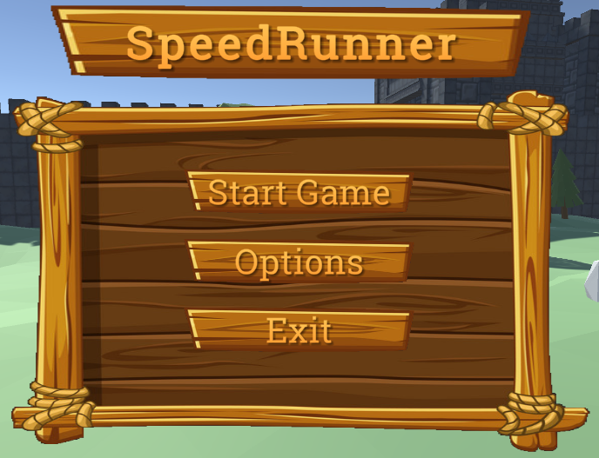

*Figure. This is the main menu – the player can navigate into gameplay, options and exit the game.*

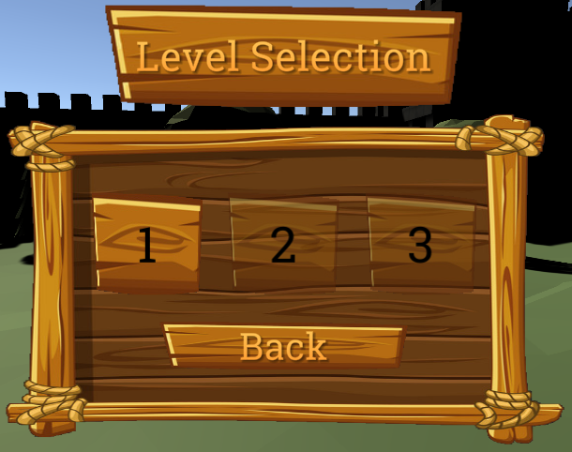

*Figure. Level selection screen – Player starts with level 1 unlocked, remaining 2 will have to be unlocked by completing the level.*

## Options Menu

This menu enables the player to control the volume of the music playing in the game, along with the main menu and reset the high score and the level completion. Resetting the **PlayerPrefs** is only accessible outside of the gameplay.

Exit will quit the application, this will work on android etc.

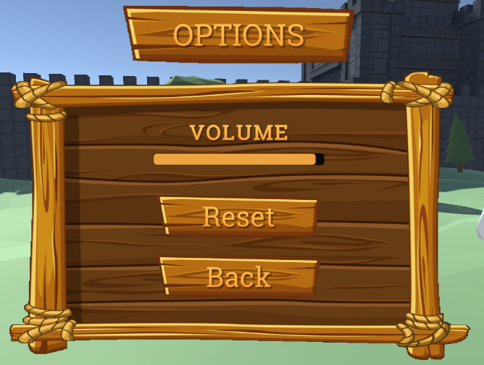

*Figure. Options menu – Player can change the volume of the music playing in the background and reset* ***PlayerPrefs*** *such as high score and levels completed.*

# In-Game Menus

In this game, there are number of in-game menus, which are designed to be well presented and easy to navigate through them. During the gameplay, player can pause the game, change the volume of the music playing in the background or simply exit the game.

As for pause menu functionality:

* Resume – Returning the player to the gameplay
* Options – Options menu allows the player to adjust the volume
* Main Menu – This brings the player back to the main menu. This will discard your achievements such as score and time and will reset player life.

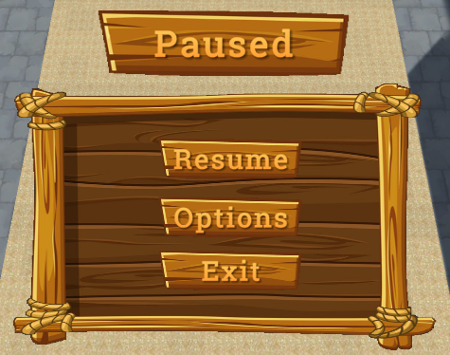

*Figure. Pause menu with three buttons, allowing player to resume the game, change volume and exit the game which will initially bring the player back to the main menu.*

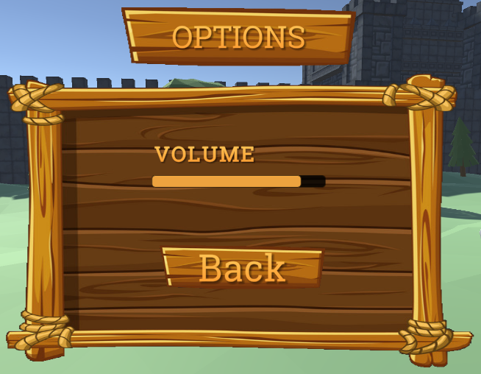

*Figure. Options menu which will allow the player to control the volume and go back to the pause menu.*



*Figure. Controls the volume using a slider which increases and decreases the volume of the music playing.*

## Splash Screens

These are the menus that appear when the player completes the level or dies. When the player completes a level, a winner menu will appear with the time of the run. When the player loses 3 lives, a game over menu will appear and will also display the time of the run. From there the player can go back to the main menu and start the game again.

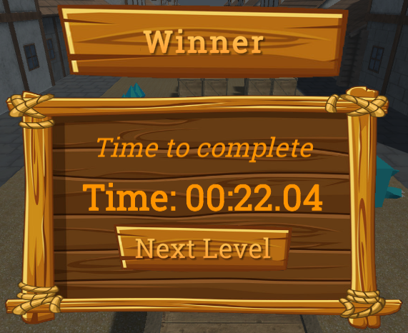

*Figure. Winner menu – Displays the time of completion of the level and by clicking ‘next level’, the player will navigate to the next level.*

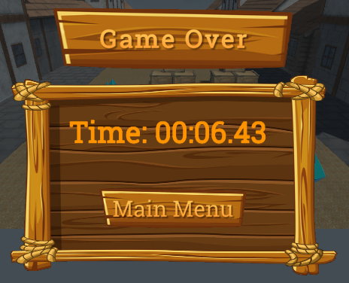

*Figure. Game over menu which displays player time of the run. From here the player can go back to main menu*

# Control Mechanisms

In games, control mechanisms are used to control the player's movement in relation to their current position. Players controls should be easy to learn and use.

In most games, the default representation for player movement using a keyboard is WASD.

## Player movement

* ‘A’ on keyboard to go left
* ‘D’ on keyboard to go right
* ‘Space’ to Jump

## WASD

The controls were designed to be WASD in the original Design document. Most of endless runner games only control the character on the x axis allowing the character to move left or right. I have contacted the designer of the game and I have arranged that this change would be more suitable for this game.

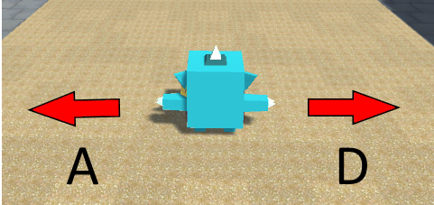

*Figure. Since the player can move on the x axis, I have assigned the controls to be ‘A’ to move to the left and ‘D’ to move to the right*

## Jump

Jumping is very important for the gameplay as it helps the player to collect coin and move between obstacles to avoid them. Making it easy for the player to move across the map with jumping, I thought of challenging the player a little bit. The jump control is designed to allow the player to jump only once, player will not be able to jump again until he touches the ground.

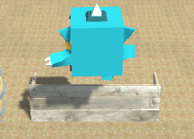

*Figure. On space the character will jump within specified area. This is designed so player can jump through some of the obstacles in his way.*

# The Game

The game begins with a camera animation which slowly moves towards the player. During this animation, player can’t move left or right, this is safety feature to eliminate any problems with the camera during the gameplay. The animation duration is set to 2 seconds. After 2 seconds all player controls are available.

Players goal is to reach the castle (level 3), in order to get to this level, player must mauver across the obstacles, kill enemies and score enough to get to the next level.

The main point of this game is to get to the end of the level with the highest score and lowest time. Since this is a single player game, there is no leader board but players high score is saved on screen. While running the player can gather items such as diamonds, kill enemies to increase the score and collect power-ups to get special abilities.

When the player reaches to the end of level, a winner menu will appear with the time they have completed the following level. There are 3 different levels, which get harder and harder as the player progresses through the game. Each level has more difficult obstacles to dodge and harder collectibles to collect. If a player loses 3 lives, a game over menu will appear and the player can restart the game which will reset the player’s score and time.

In the third level, player life is no longer visible and at this point, the player’s goal is to beat his high score. Every time the player dies, his score and time are set back to 0, making the game more challenging.

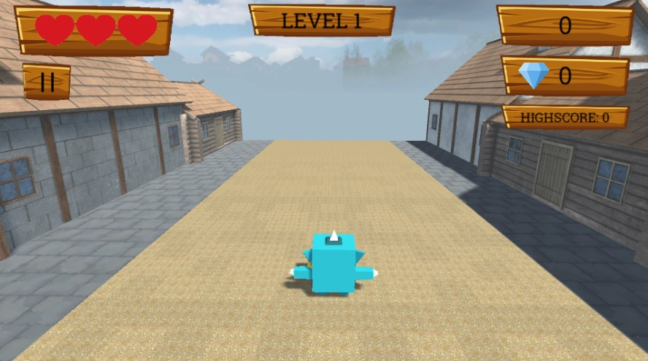

*Figure. The UI appears as soon as the game begins. Player live is to the left of the screen, just above pause button. Timer is at the right top corner, right below it’s the score and finally the high score. Each level is specified by the text at the top of the screen.*

# Level Design

Many games have difficulty levels, these are often referred as easy, medium and hard. Levels and the difficulty of them are designed to challenge the player as he progresses through the game.

In this game the levels are designed to start easy, the speed of the game is slow so the player can get used to the player controls. As the player progresses through the game, levels get harder and harder. Each level is set in a different setting, making the game more interesting and less boring. On top of this, there is a current level text of each level clearly stating what level the player is currently playing in.

Level 1 – 50 score to get to next level

Level 2 – 100 score to get to next level

Level 3 – final level, player can set his new high score

## Level Difficulty

Level 1

* Platforms are slowly spawning
* The layout of the obstacles/enemies are designed to be easy to dodge

Level 2

* Platforms spawning increases
* Obstacles/enemies harder to dodge
* Harder to collect collectibles as they are placed in difficult places
* More points to score in order to get to the next level

Level 3

* Platforms spawning increases
* Obstacles are closer to each other, making it even harder to dodge
* Harder to collect collectibles
* More enemies, harder to kill them

## Level 1

This level is set in a village, the player’s goal is to run as far as he can to get to the next level. This is designed to be basic, the speed of the gameplay is slow.

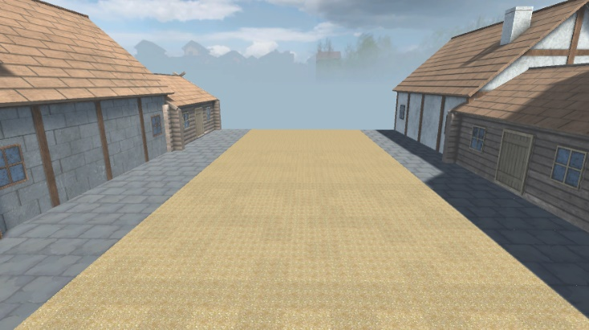

*Figure. Level 1 – Set in a village scene*

## Level 2

In Level 2, the player is located on a wall of a castle, the gameplay starts to get faster and the obstacles and enemies are harder to get past through.

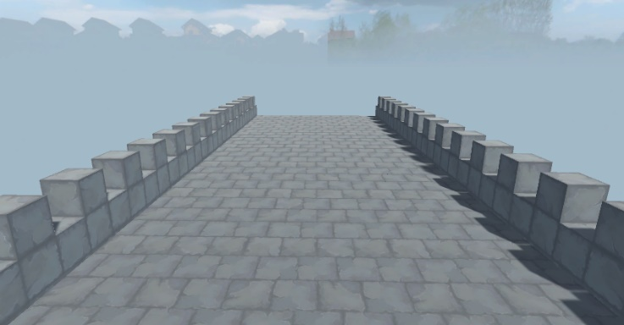

*Figure. Level 2 – Set on a wall of the castle*

## Level 3

In the last level, the player has entered the castle and the speed of the game is much faster.

This is the final level and the player’s goal is to set his high score. In this level, lives are disabled allowing the player to attempt this level as many times as he wishes. The Player can exit the game at any time, his progression will be saved. The player can choose the level he wishes to play on the level selection screen.

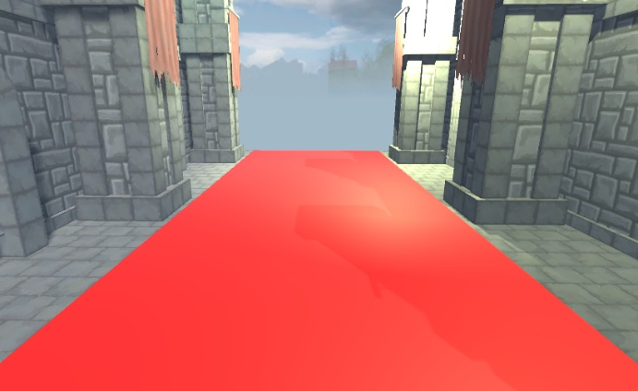

*Figure. Level 3 – Set inside of the castle*

# Enemies/Targets

In most of the games enemies are harmful to the player, causing the player to die which restarts the level. In this game enemies are not only harmful but also beneficial to the player. In this game, players have the ability to kill the enemies which will benefit the player by giving him score.

To make the game more challenging some obstacles have been added to the game. All obstacles and enemies in game are designed to kill the player by one hit.

Enemies and obstacles are randomly placed on number of different platforms which are randomly spawned. Enemies spawn at different spawn rates and have different point for kill in certain levels.

Assets used for obstacles are taken from a assets store and then built into a set of obstacles, all obstacles are then put together to form an obstacle which is made by me.

## Spawn rate

Level 1 – 20% spawn rate

Level 2- 40% spawn rate

Level 3 – 60% spawn rate

## Enemies points

Level 1 – 10 points

Level 2 – 20 points

Level 3 – 30 points

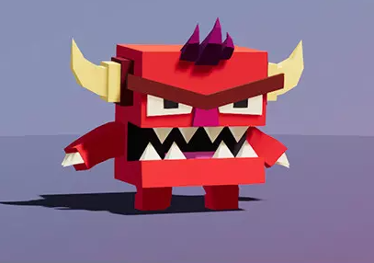

*Figure. I’m using this enemy asset as stated in the design document.*

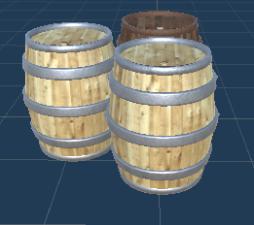

*Figure. Obstacle 1 – Barrels put together forming one obstacle.*

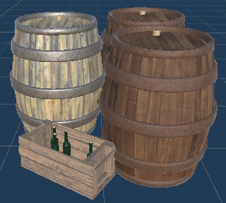

*Figure. Obstacles 2- Another set of barrels.*

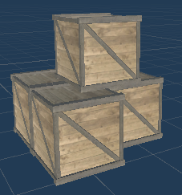

*Figure. Obstacle 3 – Set of crates*

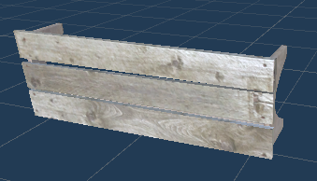

*Figure. Obstacle 4 – A bench which is rotated by 90 degrees.*

# Collectibles/Power-ups

A game without any collectables or power-ups would be quiet boring. A power-up is an item that provides the player with temporary bonuses or additional powers. In this game the collectables are diamonds that give player score, each level has different point for diamond. They are spawned on platforms randomly, they are designed to be placed in difficult places as the player progresses in different levels.

## Spawn rate

Level 1 – 10% spawn rate

Level 2 – 20% spawn rate

Level 3 – 30% spawn rate

## Collectibles

There is one collectible that is defined to add score, in this game it’s a diamond which don’t have a spawn rate and which are randomly placed on the platforms.

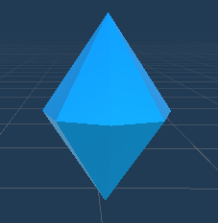

*Figure. Diamond (Diamondo) – Gives player score.*

Level 1 – 5 points

Level 2 – 10 points

Level 3 – 15 points

## Powers

There are two types of power-ups in this game.

* Double score (x2)
* Extra Life

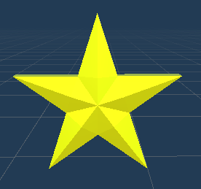

*Figure. Double Score (x2) – On pickup, when player picks up a diamond he will get score x 2. E.g. In Level 1, score per diamond is 5 when collecting this power-up player will get 10 score for 1 diamond. This is only for 1 use.*

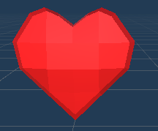

*Figure. Extra Life – On pickup, player gets additional life added. If player has 3 lives, he will not be able to collect it.*

# Sprites

Some of the sprites are taken from the internet, then edited in paint.net to accomplish an asset that would be suitable for this game.



*Figure. Used for menus, taken from the* [*internet*](https://www.google.com/url?sa=i&url=https%3A%2F%2Fstock.adobe.com%2Fsearch%3Fk%3Dwood%2520ui%2520game&psig=AOvVaw1BQCxulwKCTh19kpXhCRND&ust=1639854665303000&source=images&cd=vfe&ved=0CAsQjRxqFwoTCPC7gOvE6_QCFQAAAAAdAAAAABAD)*. Then changed in paint.net*



*Figure. Used as background for texts. Taken from the same picture as the above sprite.*



*Figure. Used as an image for the coins. Taken from the* [*internet*](https://www.google.com/url?sa=i&url=https%3A%2F%2Fmobile.twitter.com%2Fgem&psig=AOvVaw2ksBYgzbTMUyoP44SYoqBV&ust=1639854894387000&source=images&cd=vfe&ved=0CAsQjRxqFwoTCMDvqtbF6_QCFQAAAAAdAAAAABAD)

# Problems & Learning

## Problems with platforms spawning

During the implementation of this game, I ran into number of problems which we’re a challenging to me.

Just at the start of implementing this game, I had problems with the platforms spawning. I had few issues with my platforms, one of the problems were that the platforms were spawning on top of each other rather than in front of the player. Another problem was that only selected number of platforms were spawning, but they were not enabling and disabling as they go. Final problem was that my platforms were set to static, which caused my default platform not to scroll with the rest of the platforms.

To fix this I had to *uncheck* ***static*** for all my platforms and *select a* ***mesh*** in the mesh collider.

## Problem with camera animation

When implementing camera animation I ran into a problem. During the animation the player can still move and this caused to brake the main camera. I did some research and to fix this problem I had to enable player movement during the animation, this fixed the problem.

## Learning outcome

I have learned a lot during the implementation of this game. 3D games are a lot harder compare to 2D in my opinion. Although I have learned a lot in this course from the weekly labs. I really enjoyed implementing this game as this is my first proper 3D game.

# Build Settings

In order for the level selection to work properly, all levels must be add like below.

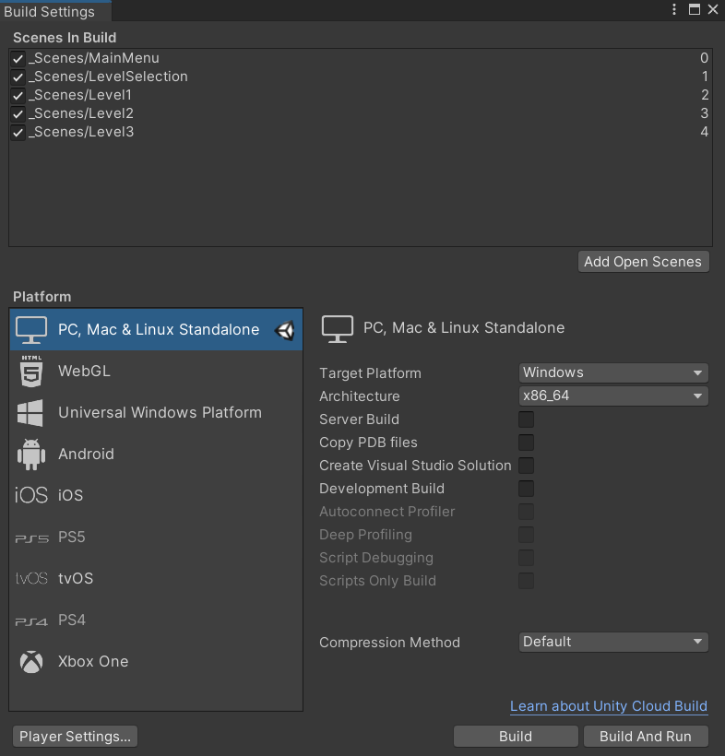

# Test Plan

I have created the test plan using Excel. Csv file will be also attached with the submission.

# References

Assets

* <https://assetstore.unity.com/packages/3d/characters/meshtint-free-boximon-fiery-mega-toon-series-153958>
* <https://assetstore.unity.com/packages/3d/characters/meshtint-free-boximon-cyclopes-mega-toon-series-154436>
* <https://assetstore.unity.com/packages/3d/props/free-medieval-props-asset-pack-131420>
* <https://assetstore.unity.com/packages/3d/props/simple-gems-ultimate-animated-customizable-pack-73764>
* <https://assetstore.unity.com/packages/3d/environments/dungeons/cartoon-castle-building-kit-128637>